Vadim Kolotenko  Haaga-Helia ammattikorkeakoulu  Linux-palvelimet - ICI003AS2A-3021 | Raportti 1  20.8.2026

Introduction
The main assignment of the first session was to install Debian on a virtual machine. My task was to set up the system and configure it for further work.

Debian Installation
I used VirtualBox 7.2.16 on Windows 11. The ISO image was downloaded from the official Debian website (debian-live-13.6.0-amd64-xfce.iso).
In the virtual machine settings, I allocated 4 GB of RAM, 4 CPU cores, and a 20 GB virtual disk. EFI was left enabled.
The OS booted into the Live environment. I verified that the system had an internet connection by opening the browser. After that, I launched the installer shortcut on the desktop.
I set the following values:
- Language – English
- Time zone – Helsinki
- Keyboard layout – English US (I will change it to Finnish later if needed)
- Disk partitioning – erase the disk
- Assigned a computer name, a username, and a password.

Screenshot of installed Debian.

Guest Additions
Guest Additions installed without any workarounds. I clicked "Devices" -> "Insert Guest Additions CD Image..." and the disc image appeared on the desktop. Then I used the following sequence of commands:
sudo apt update
sudo apt install build-essential linux-headers-$(uname -r)
^ without these commands I got an error, which I googled. I found these commands as the solution.
cd /media/lolofost/VBox_GAs_7.2.16/
sudo ./VBoxLinuxAdditions.run
sudo reboot
In the VirtualBox settings I enabled Bidirectional Shared Clipboard, and it works without any issues, so I assume the guest additions are functioning properly.

OSS
The article “What Is Open Source Software and Why Use OSS?” explains the meaning of open source. The main idea is that open-source software gives users and developers freedom – they can view and analyze the code, modify it to suit their needs, and distribute their own versions.
The advantages include the ability to analyze the code for security issues before installing the software itself. Bugs are fixed faster because anyone can propose a solution, and the maintainer only needs to accept it. Such projects have more active communities. Different licenses, such as GPL, MIT, and Apache, define the conditions of use and distribution.
Without open-source projects, Linux and a huge number of modern tools would not exist.

Conclusion
This course is my first experience with VirtualBox, so I am dealing with OS virtualisation for the first time. It is also my first time installing Debian specifically. Previously, I have installed Linux Mint on a laptop as a primary desktop system, and about a month ago I installed Ubuntu Headless on my old computer, which now runs 24/7 as a server. On that server I have CasaOS installed, and I manage Docker containers mainly through Portainer. I already have a basic understanding of Linux systems, but I am confident that I can learn new things on this course, so I am ready to continue working.

Sources
- Debian CDImage: https://cdimage.debian.org/debian-cd/13.6.0-live/amd64/iso-hybrid/ (accessed 18.08.2026)
- Coursera: https://www.coursera.org/articles/what-is-open-source-software (accessed 20.08.2026)

Attachments
Attachment 1. Debian
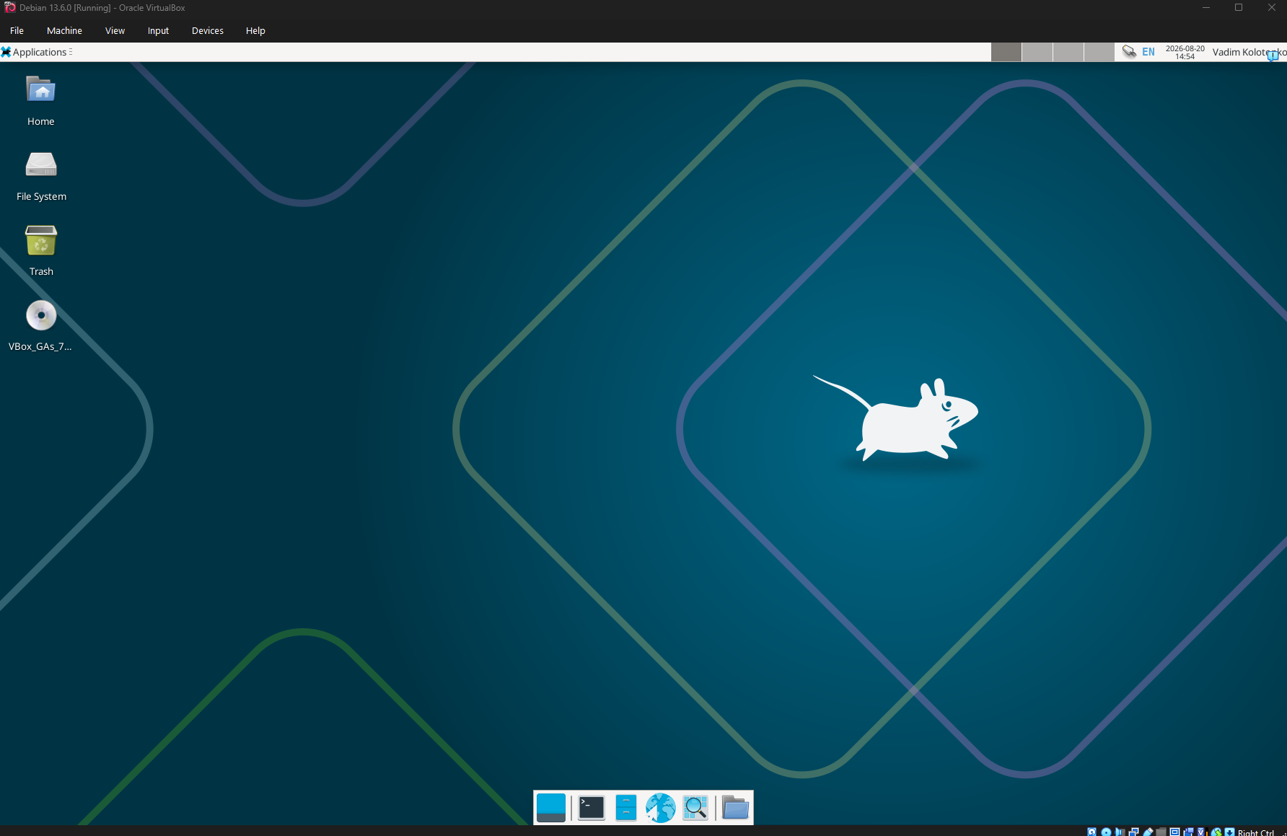
Attachment 2. CasaOS
